After the Edge of the World

I. Where the Maps Once Ended
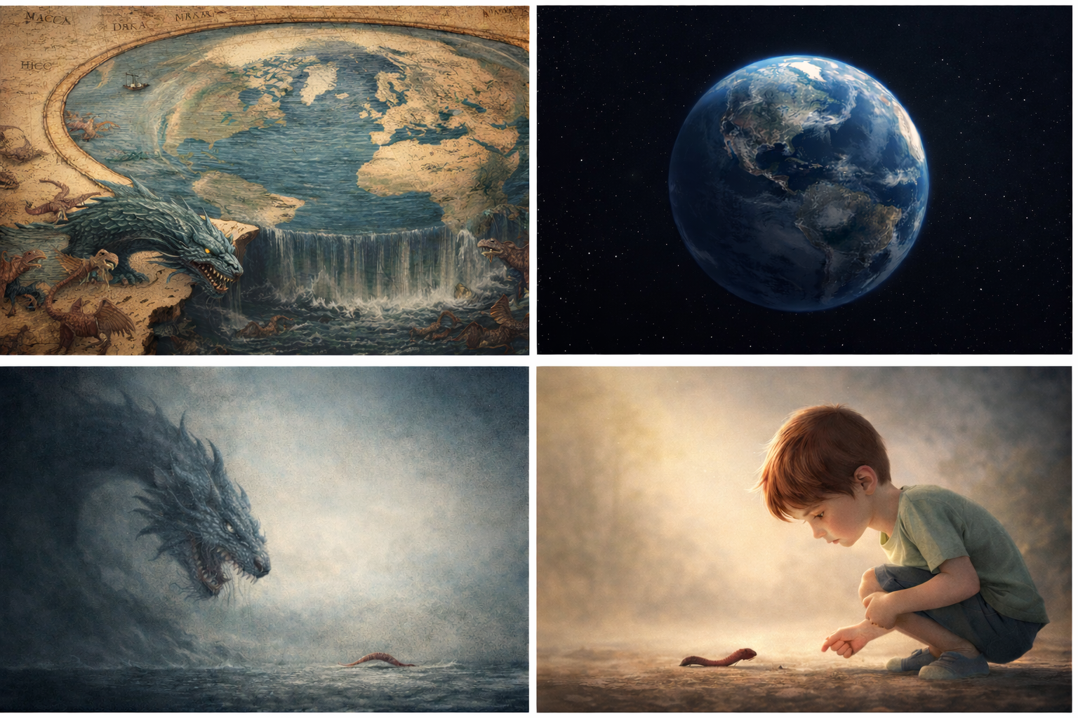
There was a time when the sea did not merely stretch beyond the horizon — it ended.
Maps faded into parchment-colored mist. Inked waves curled into claws. At the margins were drawn the necessary warnings:
Here be dragons.
Or worse — Leviathan.
The monster was not just a creature.
It was a boundary.
It marked the place where human capacity stopped.
Beyond that line, only God could rule.
And so the phrase entered the imagination:
Only God can tame the Leviathan.
It was not defiance.
It was an admission of scale.
We did not have the ships.
We did not have the instruments.
We did not have the coordination.
The sea was not evil.
It was simply larger than us.

II. When the Edge Dissolved
And then something quiet happened.
We built better hulls.
Better maps.
Better mathematics.
Better institutions.
The edge did not disappear because we prayed harder.
It disappeared because we measured.
The dragons receded into bathymetry.
The abyss became data.
The monster became contour lines.
The sea did not shrink.
We grew.
What once required divine mastery required navigation, cartography, and eventually orbital perspective.
We did not defeat the ocean.
We learned to read it.

III. The New Leviathan
Today the sea is calm compared to what we have built.
Our Leviathan is not scaled and submerged.
It is composed of planetary networks,
interdependent supply chains,
accelerating technologies,
systems that respond faster than our instincts.
The chaos is real.
Feedback lags are real.
Cascades are real.
Fragility is real.
We are not outside the Fermi equation.
Civilizations can still outrun their own feedback.
Acceleration can still exceed adaptation.
But the monster is no longer mythic.
It is systemic.
And systemic forces are not tamed by prophecy.
They are tamed by feedback.

IV. From Divine Mastery to Mature Humans
There was a time when only God could tame Leviathan.
What once required divine mastery now requires mature humans.
Not cavemen with fire and fear.
Not superstition dressed in modern vocabulary.
Not sensationalism designed to frighten.
But grown civilizations capable of:
measuring what they deploy,
pacing what they accelerate,
coordinating beyond tribe,
restraining without paralysis.
The problem of scale is not metaphysical.
It is developmental.
A child fears the dark.
An adult installs lighting.

V. The Monster Shrinks
The ancient Leviathan filled the sea.
Today, when seen from orbit, the monster is smaller.
Not because power diminished.
But because perspective expanded.
The beast that once seemed cosmic now resembles something coiled and complex — but observable.
A serpent is not less dangerous than a dragon.
But it is measurable.
And what is measurable is governable.
Leviathan has not disappeared.
It has changed form.
The sea is quieter now.
The dashboard is louder.
The question is no longer whether the beast can be tamed —
but whether we are willing to measure it.
The sea is no longer the edge.
The edge is maturity.

