Adaptive Node Emergence and the Symbiosis Condition
  - Copy-text subsection with diagrams, prior-work positioning, novelty statement, and references
Position in the framework. This subsection sits below the level of institutions and asks how stable symbiosis is maintained at the scale of persons, relationships, and small triads. The central claim is that adaptive node formation at the interpersonal scale is the micro-foundation of the broader symbiosis condition ΔT/t = B(H).

1. Core Subsection Text
Let each person i be represented by a composite bubble field q_i(x,t)=Σ_k a_ik(t) q_ik(x,t), where the index k runs over PERSIA nodes or related capability dimensions. The bubble is therefore not a rigid sphere but a deformable membrane of internal sources. In this formulation, relationships are not edges first and geometry second; they are shared regions of field overlap generated directly by the interacting bubbles.
For two individuals i and j, define the relationship field r_ij(x,t)=κ_ij(t) q_i(x,t) q_j(x,t). The overlap product preserves locality and positivity: the relationship is strongest where both bubbles are simultaneously strong. This gives a natural mathematical description of the shared boundary region. If κ_ij remains high, the shared node stays centered and the relation remains symbiotic; if κ_ij declines, the overlap thins and the node migrates toward the dominant bubble, producing early capture or eventual separation.
The oscillatory term should be preserved, but as modulation rather than as the primary bubble definition. A raw cosine field can create additional nodes that are not stable primary overlaps. In a human system those oscillations need not be dismissed as mere artifacts: they can be interpreted as weaker resonance zones, indirect ties, alternating trust, or antagonistic substructure. A convenient form is r_ij(x,t)=κ_ij(t) q_i(x,t) q_j(x,t) cos(φ_ij(x,t)). The Gaussian overlap gives the true shared region; the cosine term contributes internal organization, resonance, and phase-sensitive structure.
The triad is the first scale at which adaptation becomes structurally important. With three individuals A, B, and C, the local cluster field is M_3(x,t)=q_A+q_B+q_C+λ(r_AB+r_BC+r_AC). If one node weakens, the system need not collapse immediately. The weaker participant can deform its bubble and increase a previously underused node—music, knowledge, mediation, toolmaking, or another tradable capability. In that sense, learning, specialization, and creativity are not optional embellishments; they are adaptive responses required to preserve overlap and keep the triad from breaking.
This yields the local symbiosis condition. Let N_i denote emergent node capacity for person i. Then relational strain, trust structure, and environmental pressure jointly induce a local adaptive law of the form dN_i/dt = B(H_i, σ_i, κ_ij, κ_ik, …), where H_i is human adaptive capacity and σ_i measures deformation or strain. Stable symbiosis requires the rate of adaptive node emergence to remain at least as large as the rate at which pressure, mismatch, or role asymmetry grows. In words: stability requires adaptive human expansion at least as fast as pressure grows. This is the small-scale expression of the broader condition ΔT/t = B(H).
Interpretive summary: trust and reciprocity maintain a centered shared boundary; asymmetry shifts the node; adaptation creates new value-bearing nodes; excessive deformation without successful renewal leads to frustration, thinning of the overlap, and separation.

2. Diagrams
The diagrams below keep the construction deliberately local. They show how the field picture builds from centered overlap to node migration and then to triadic adaptation.
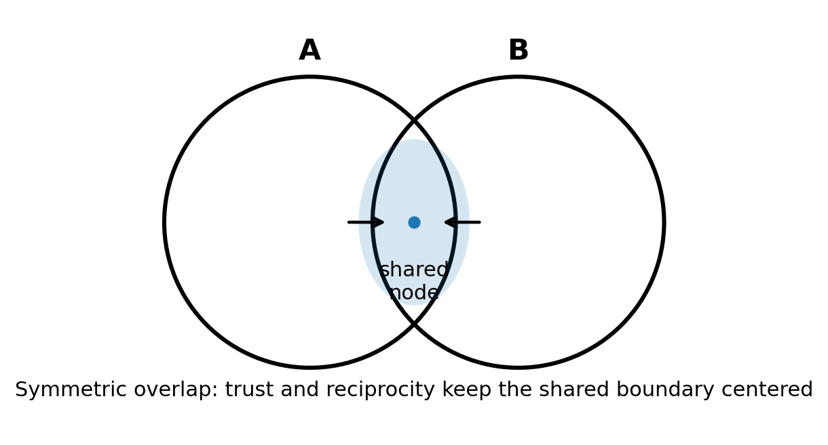
Figure 1. Symmetric dyad. Trust and reciprocity keep the shared node centered.
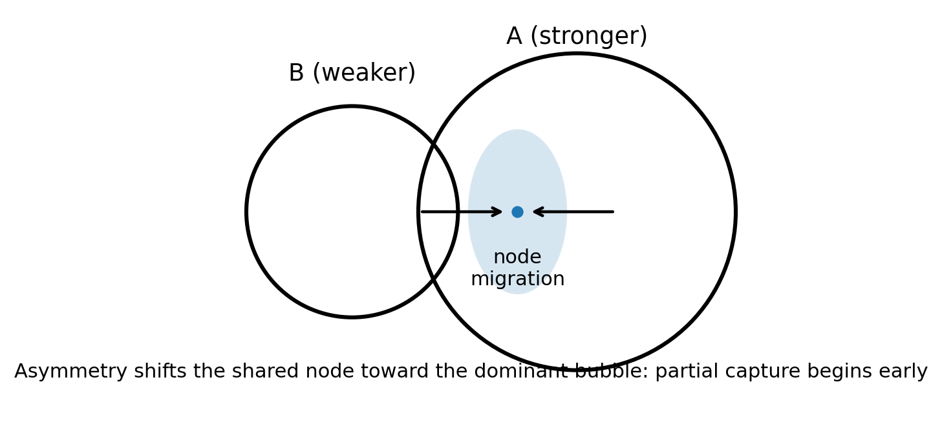
Figure 2. Asymmetric dyad. The shared node migrates toward the stronger bubble, marking partial capture.
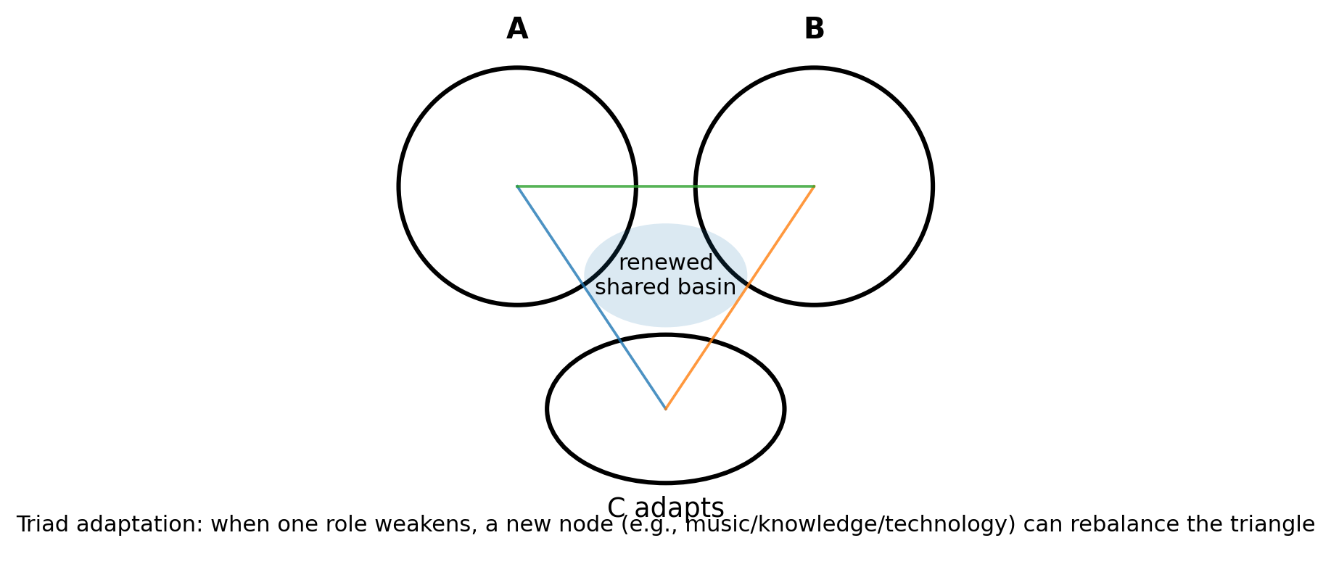
Figure 3. Adaptive triad. A weakened third participant can deform and activate another node to restore a shared basin.

3. Relation to Prior Work
The behavioral content is not new in itself. Cooperation, reciprocity, exploitation, and role renegotiation are central themes in repeated-game models and the evolution-of-cooperation literature, including Axelrod and Hamilton’s iterated Prisoner’s Dilemma analysis and Nowak’s synthesis of reciprocity mechanisms.
Triads are also well established in social theory. Heider’s balance theory and Cartwright–Harary structural balance formalized how three-way relations tend toward balanced or imbalanced configurations.
What differs here is the representation. Standard game-theoretic and signed-network formulations usually treat individuals as discrete players or graph nodes connected by payoffs or signed edges. The present formulation treats persons as continuous influence bubbles, relationships as overlap regions, and larger institutions as membranes extracted from the aggregate field. On the mathematical side, the interfacial language is closer to diffuse-interface and phase-field models than to standard network notation; Cahn–Hilliard type free-energy functionals are a natural template for finite-thickness boundaries and interfacial energy.

4. Difference from Prior Work and Novelty (Cautious Statement)
To my knowledge, the novelty is not in claiming that trust, reciprocity, capture, coalition drift, or adaptation exist. Those are already treated across game theory, social balance theory, cooperation studies, and complex adaptive systems research.
The possible novelty lies in the translation: (i) individual agents are modeled as continuous bubbles built from internal PERSIA-like node fields; (ii) relationships are represented as shared overlap regions rather than edges alone; (iii) trust enters as a coupling coefficient on an explicitly spatial bridge field; and (iv) larger social and institutional structures are represented as membranes or level sets generated by the combined person-plus-relationship field.
If that representation proves useful, then the framework offers a common mathematical language from interpersonal trust to civilizational boundary formation. In that sense, the micro-scale adaptation law here supplies a bottom-up foundation for the macro symbiosis condition ΔT/t = B(H), rather than introducing a separate macro rule disconnected from lived human interaction.

5. Short Lock-Down Statement
Adaptive node emergence is the micro-foundation of symbiosis. A shared relationship remains stable when trust-weighted overlap is preserved and when human adaptive capacity can generate new value-bearing nodes fast enough to offset strain, mismatch, and asymmetry. When that adaptive response fails, overlap thins, the node migrates, and the relation moves toward capture, separation, or collapse.

References
Axelrod, R., & Hamilton, W. D. (1981). The evolution of cooperation. Science, 211(4489), 1390–1396.
Nowak, M. A. (2006). Five rules for the evolution of cooperation. Science, 314(5805), 1560–1563.
Heider, F. (1946). Attitudes and cognitive organization. Journal of Psychology, 21, 107–112.
Cartwright, D., & Harary, F. (1956). Structural balance: A generalization of Heider’s theory. Psychological Review, 63(5), 277–293.
Holland, J. H. (1992). Complex adaptive systems. Daedalus, 121(1), 17–30.
Ostrom, E. (2009). A general framework for analyzing sustainability of social-ecological systems. Science, 325(5939), 419–422.
Cahn, J. W., & Hilliard, J. E. (1958). Free energy of a nonuniform system. I. Interfacial free energy. Journal of Chemical Physics, 28(2), 258–267.

