Human Technology Transition to Symbiosis

1. Human Cognitive and Adaptive Band
Potential→Velocity (P→V) conversion describes how latent technological capability (P) becomes deployed societal capability (T_deploy). In unconstrained systems, economic and competitive pressures drive rapid conversion such that dT_deploy/dt ≈ rT. Symbiotic stability requires that this conversion be bandwidth-limited by adaptive capacity B(H), so that deployment velocity does not exceed societal absorption. Thus the central control requirement becomes dT_deploy/dt ≤ B(H).
We begin with a simple, explicit systems claim: the human side of a civilization has a finite bandwidth for absorbing and stabilizing new capability. This is not a moral claim. It is an engineering constraint arising from learning rates, organizational inertia, coordination overhead, and institutional update cycles.

1.1 Definitions
Let the following time-dependent state variables describe the coupled system:
Symbol | Meaning | Units / Notes
H(t) | Human adaptive capacity (effective assimilation/coordination capacity) | dimensionless index; can be scaled
H_max | Upper bound (structural adaptive ceiling) | dimensionless index
a | Adaptation rate constant | 1/time
T(t) | Deployed technological capability (effective capability in the field) | dimensionless index; can be scaled
r | Capability growth rate (raw technological trajectory) | 1/time
T_deploy(t) | Deployed capability after pacing / gating | dimensionless index
G(t)=T/H | Gap ratio (mismatch index) | dimensionless
B(H) | Adaptive bandwidth (max safe deployment rate) | capability units/time

1.2 A minimal adaptation model
We model adaptive capacity as a saturating process. Early on, institutions can retool quickly; later, marginal adaptation becomes harder due to complexity, coordination costs, and path dependence. A compact model is:
dH/dt = a (H_max − H)
with solution:
H(t) = H_max − (H_max − H_0) e^{−a t}
Interpretation: a sets how quickly a society can climb its adaptation curve; H_max is not a constant of nature—it can be expanded by redesigning institutions, training systems, standards, interfaces, and governance.

1.3 What H includes
H(t) is a *system-level* variable. It bundles multiple layers:
• Cognitive layer: education, skill transfer, conceptual literacy
• Organizational layer: workflow redesign, QA practices, incident response
• Institutional layer: norms, law, enforcement capacity, legitimacy
• Technical integration layer: tooling, interfaces, verification, monitoring
In practice, different sectors have different H(t). We use an aggregate H(t) to reason about civilization-scale stability.

2. Technological Capability Divergence
Let T(t) denote effective deployed capability *if deployment were unconstrained*. Many technology trajectories are well approximated as exponential in early-to-middle phases due to compounding improvement and investment feedback.

2.1 Minimal capability growth model
dT/dt = r T
with solution:
T(t) = T_0 e^{r t}
Here r is an effective growth rate that includes algorithmic improvements, hardware scaling, and capital expansion. This is intentionally agnostic about the micro-causes; we are building a macro-stability model.

2.2 The mismatch gap ratio
Define the gap ratio (mismatch index):
G(t) = T(t) / H(t)
G(t) is not ‘good’ or ‘bad’ by itself. It is a diagnostic variable: when G is small, the human system can track capability changes; when G is large, the system operates outside its stable envelope.

3. Leviathan Systems: Definition, Contemporary Manifestation, and Fermi Context
In earlier work the term Leviathan system was introduced to describe large-scale technological–infrastructural organisms whose scale, coupling, and fixed-cost dominance place them beyond ordinary institutional control. Such systems exhibit three defining properties: (1) exponential capability scaling, (2) utilization-sensitive stability, and (3) societal embedding. These properties make their stability dependent on the symbiotic condition.

3.1 Defining properties of a Leviathan system
• Exponential capability core: underlying technological capacity T scales rapidly with investment and innovation.
• Fixed-cost dominance: viability depends on sustained utilization U = D/K.
• Societal embedding: demand D depends on adaptive integration Φ(H,G).
• Control asymmetry: deployment velocity can exceed adaptive bandwidth without deliberate pacing.
• Systemic externality: instability propagates beyond sector boundaries.
These properties can be summarized by the coupled relations:
U = D(H,G) / K
G = T_deploy / H
When G grows beyond corridor tolerance, demand collapses and utilization destabilizes, producing systemic stress.

3.2 Contemporary Leviathan manifestations
Real-world manifestations of instability appear when deployment outpaces adaptive acceptance. Examples include energy allocation tensions where high-density compute infrastructures compete with civil energy needs, and surveillance-capable systems deployed prior to societal legitimacy formation. In both cases G rises: capability enters society faster than adaptive norms, institutions, or trust can stabilize exchange. Resulting backlash—regulatory, cultural, or economic—reflects exchange asymmetry rather than technological rejection per se. These dynamics empirically illustrate the symbiosis condition.
Modern civilization contains multiple Leviathan-class systems: global computational infrastructures, AI capability networks, planetary-scale energy grids, financial clearing architectures, and integrated supply chains. All share exponential capability growth coupled to societal absorption limits. The present state of affairs—rapid deployment pressures, regulatory lag, institutional saturation, and utilization volatility—matches the predicted Leviathan divergence regime.

3.3 Leviathan within the symbiosis framework
In the symbiosis model Leviathan systems form a subset whose stability depends on the deployment–adaptation inequality:
dT_deploy/dt ≤ B(H)
When satisfied, capability growth remains within adaptive bandwidth and utilization remains stable. When violated, gap G grows, demand destabilizes, and Leviathan enters divergence. Thus Leviathan stability is mathematically equivalent to symbiotic stability.

3.4 Leviathan and Fermi civilizations
The Fermi question—why advanced civilizations are not widely observed—can be reframed in Leviathan terms. Civilizations reaching planetary-scale capability inevitably create Leviathan systems. If these systems diverge (G↑, U↓), civilizational coherence degrades before interplanetary expansion becomes stable. Only civilizations that achieve symbiotic regulation of Leviathan systems can maintain long-horizon infrastructure required for expansion.

3.5 Symbiosis as prerequisite for space stability
Interplanetary and interstellar infrastructures amplify Leviathan properties: higher fixed costs, tighter reliability margins, and longer adaptive horizons. Stability therefore requires effective mutually beneficial symbiosis prior to expansion.
Space stability ⇒ dT_deploy/dt ≤ B(H) ∧ G ≤ G* ∧ U stable
Thus the capacity to tame Leviathan through symbiotic control is not merely desirable but a prerequisite for sustained civilizational expansion.

3.6 When does the gap grow?
Differentiate ln G to obtain a clean growth condition:
d/dt [ln G] = d/dt[ln T] − d/dt[ln H] = r − (1/H)·dH/dt
Using dH/dt = a(H_max − H):
d/dt [ln G] = r − a (H_max/H − 1)
Thus the gap grows when r exceeds the *effective* adaptation rate term. As H approaches H_max, the term a(H_max/H − 1) declines toward 0—meaning sustained exponential T will eventually widen G unless deployment is paced or H_max expands.

Figure 1. Leviathan–Symbiotic Phase Map (Years Overlay)
This map overlays T(t), H(t), G(t), utilization proxy U(t), and the symbiotic rate-match proxy S(t) on a year axis. It is a conceptual regime map, not a precise forecast.
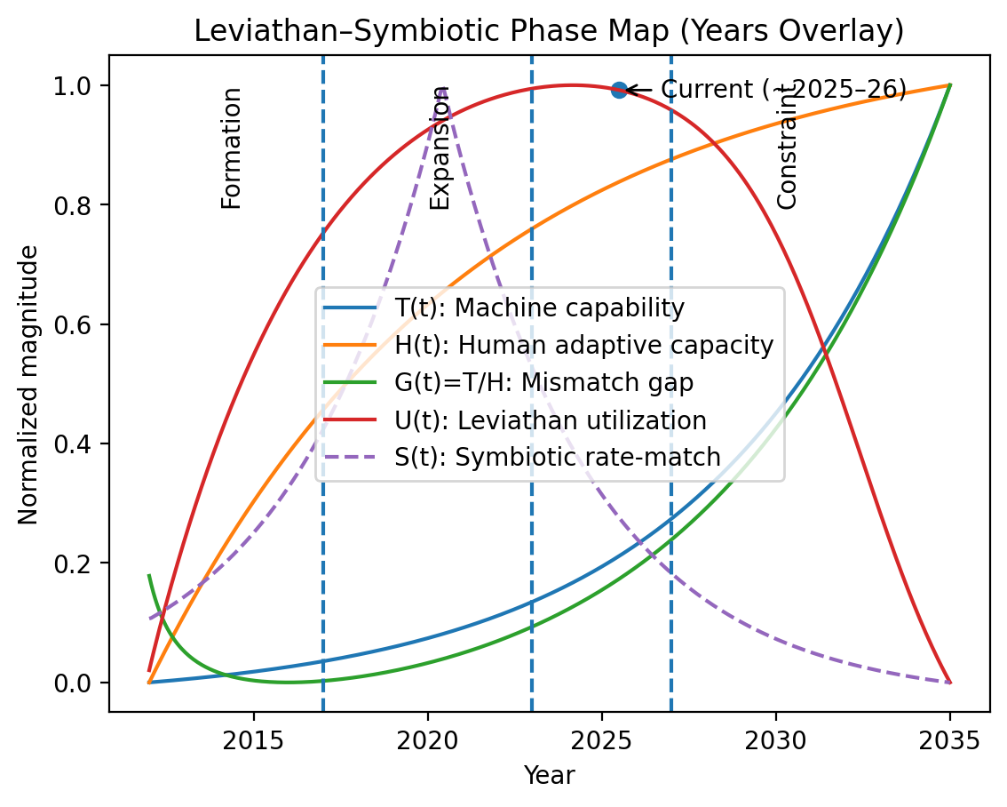
Figure 1. Phase map with approximate year mapping (illustrative).

4. Core Rate-Mismatch Model and the Stability Condition
The central systems claim is a rate constraint: stable co-evolution requires that deployed capability growth remain within adaptive bandwidth. This is the control-theoretic heart of the symbiosis framework.

4.1 Deployment vs raw capability
Distinguish raw capability growth T(t) from deployed capability T_deploy(t). In real systems, deployment is mediated by release gating, verification, compliance, and interface constraints. We model this as a controllable deployment rate.
dT_deploy/dt ≤ B(H)
B(H) is the adaptive bandwidth: the maximum safe rate of deployment that the human system can absorb at state H.

4.2 A natural form for B(H)
A simple and interpretable choice ties bandwidth to *actual* adaptation rate:
B(H) = κ · dH/dt = κ a (H_max − H)
κ is a proportionality constant capturing how much deployment can be tolerated per unit of adaptation. In practice, κ depends on the risk profile of the domain (medical, aviation, finance, etc.).

4.3 Symbiotic regime definition
Define the symbiotic regime as rate-matched co-evolution:
dT_deploy/dt ≈ dH/dt (up to a domain-dependent constant)
Equivalently, the gap remains bounded:
G(t) = T_deploy/H ≈ constant (or constrained within a corridor)

Figure 2. Symbiotic rate-match proxy
We use a smooth rate-match proxy S(t)=exp(−|ln( dT_deploy/dH )|) that peaks when deployment rate matches adaptation rate.
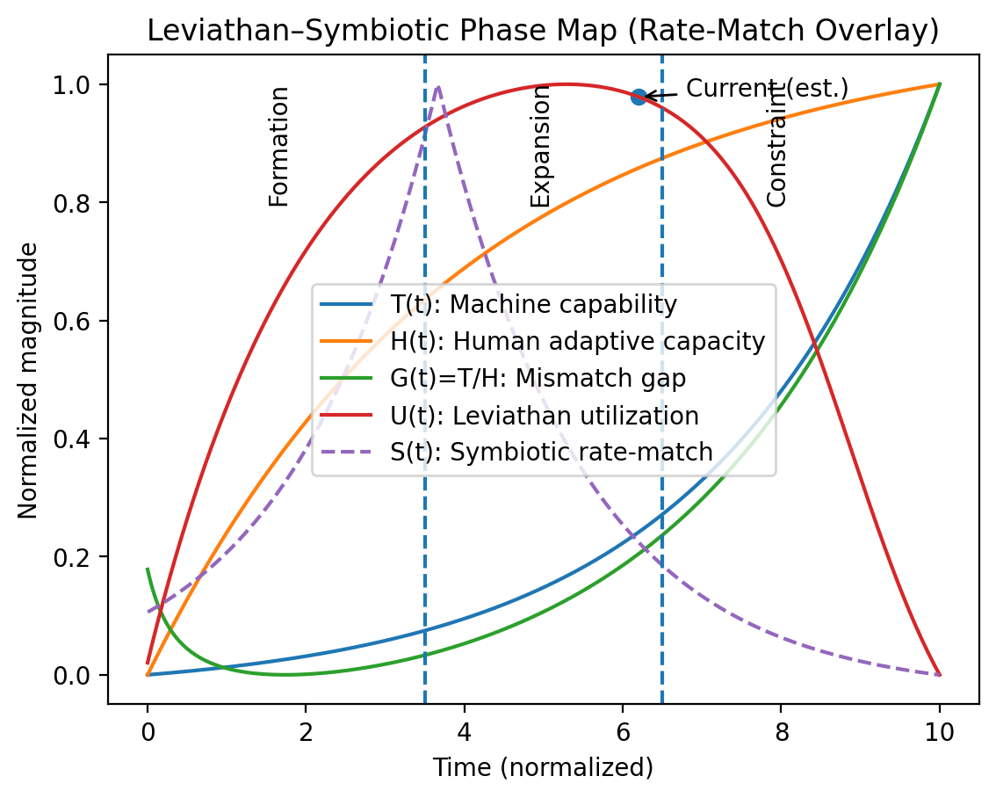
Figure 2. Rate-match peaks near the stability ridge where adoption is fastest and mismatch remains tolerable.

5. Why policy-only slope changes rarely change direction
A recurring observation in technology governance is that interventions often change the slope of deployment or diffusion without changing the long-run direction of divergence. In the model, many interventions modify parameters (r, a, κ) but do not address the structural mismatch between exponential growth and saturating adaptation.

5.1 Parameter modulation vs regime change
Suppose a policy reduces r to r′ or increases a to a′. This can delay divergence, but if the system remains open-loop and deployment tracks raw capability, the inequality d/dt ln G > 0 can still hold asymptotically.
d/dt [ln G] = r′ − a′(H_max/H − 1)
Regime change requires introducing deployment control (pacing) and/or expanding H_max structurally. That is the shift from ‘parameter tuning’ to ‘control architecture’.

6. The Symbiotic Control Architecture
The symbiosis model is not a slogan. It is a control architecture for keeping the coupled system within a stable envelope. The envelope can be expressed as a corridor for the gap ratio.

6.1 Symbiotic corridor
Define a tolerance threshold G* and an operating corridor:
G_low ≤ G(t) ≤ G*
G* is domain dependent. In high-risk domains, G* is smaller. The corridor expresses ‘how far ahead’ capability can run before institutions lose the ability to validate, govern, and integrate safely.

Figure 3. Location relative to the symbiotic corridor
This plot makes the ‘where are we relative to the symbiotic line?’ question explicit.
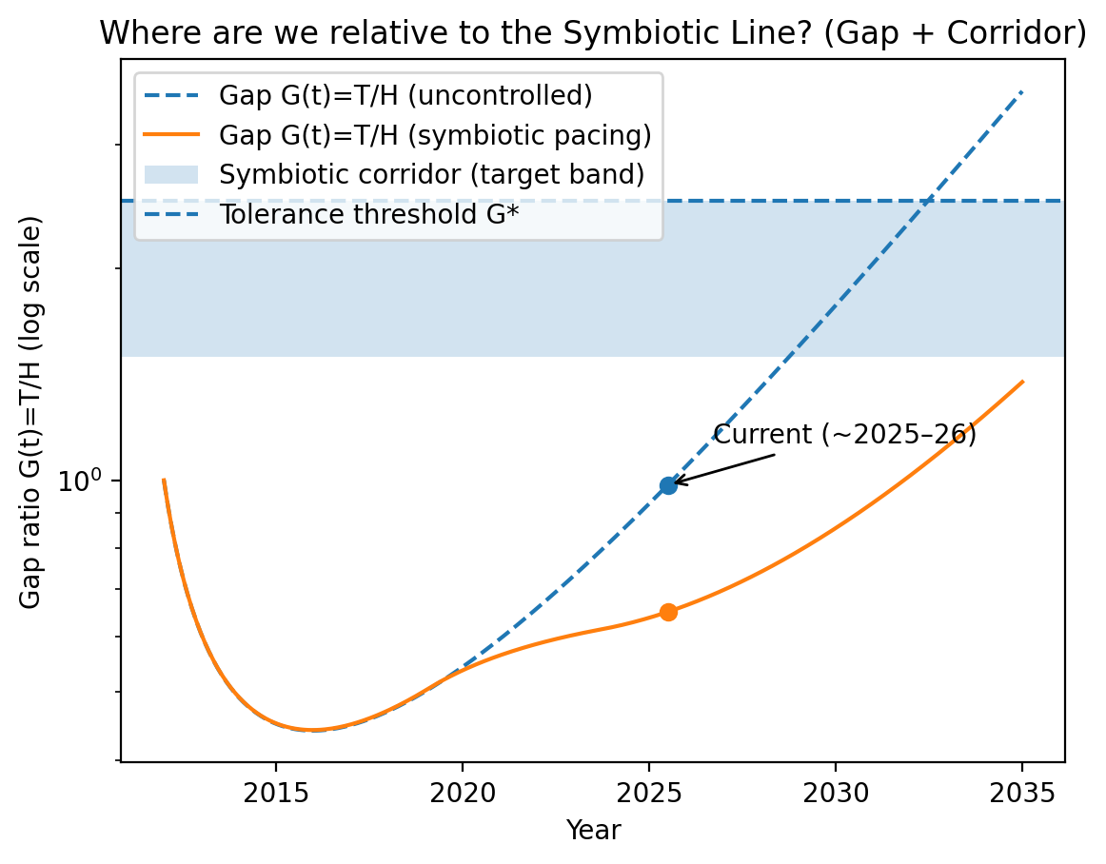
Figure 3. Gap trajectories with a conceptual corridor and tolerance threshold.

7. Leviathan Infrastructure as a Subsystem of Symbiosis
The Leviathan model describes the stability of capital-intensive compute infrastructure under utilization constraints. It is a *subset* of the symbiosis framework because demand stability depends on adaptive integration.

7.1 Utilization and fixed-cost dominance
Let K be installed capacity, D effective demand, and utilization:
U = D / K
In a fixed-cost-dominant regime, viability is highly sensitive to utilization. A utilization shock can trigger a cost spiral.

7.2 Demand depends on adaptation and gap
Model demand as a function of the adaptive state and mismatch:
D(t) = D_0 · Φ(H(t), G(t))
When G exceeds tolerance, Φ can drop sharply (loss of trust, integration friction, regulatory pauses, incident-driven freezes). Therefore Leviathan stability reduces to keeping G bounded—i.e., to the symbiosis condition.

Figure 4. Leviathan regimes: uncontrolled vs symbiotic
Same infrastructure, different deployment regime. The symbiotic regime prevents utilization collapse by bounding mismatch.
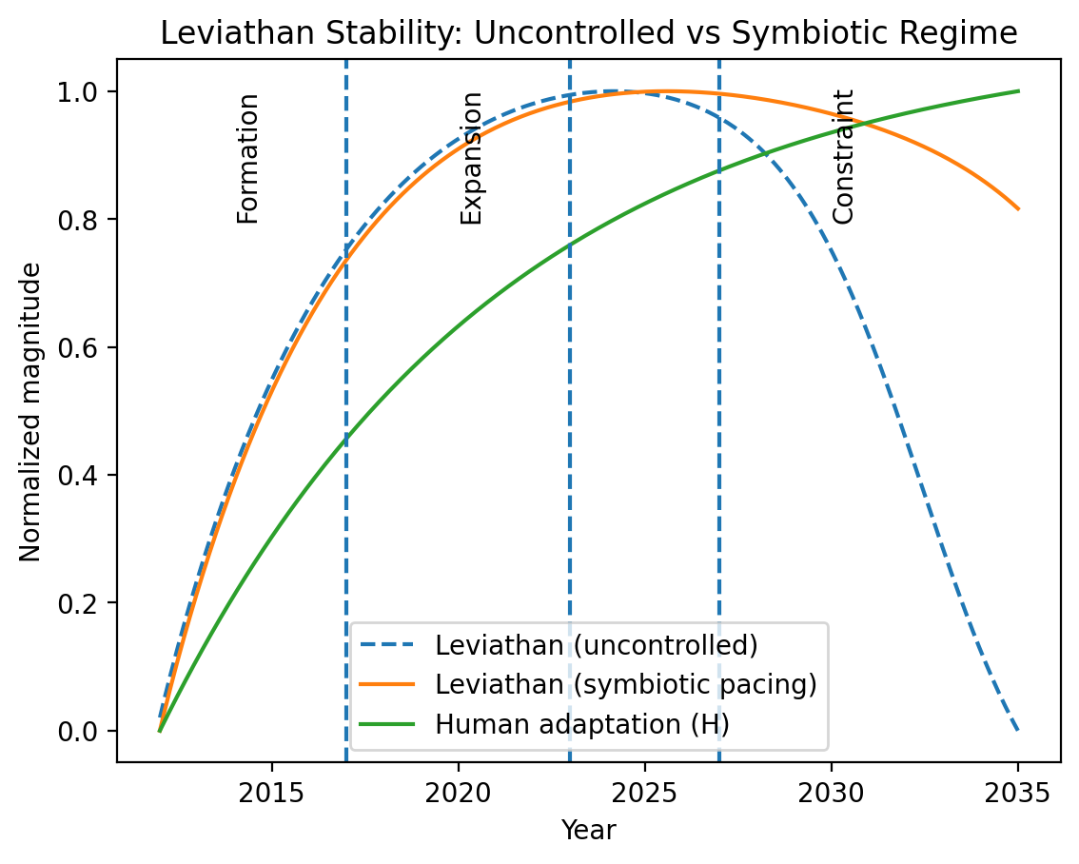
Figure 4. Uncontrolled divergence destabilizes utilization; symbiotic pacing stabilizes it.

8. The Symbiotic Fermi Boundary and Why Stabilization Precedes Space Expansion
This section sharpens the phrase ‘expansion capability’. Expansion means sustained, multi-generation, high-reliability coordination across long time horizons—precisely what interplanetary infrastructure demands. A civilization can have high local capability yet fail to cross this boundary if its coupled human–technology system is unstable.

8.1 A boundary condition stated as an inequality
Define a civilizational tolerance threshold G* such that stable expansion requires:
G(t) = T_deploy(t)/H(t) ≤ G* for sustained periods
Interpretation: the capability presented to society must remain within its ability to validate, govern, and integrate. If G violates this for extended periods, coordination fractures and large projects fail to maintain continuity.

8.2 A Fermi-style interpretation
In Fermi terms: why don’t we observe ubiquitous cosmic expansion? One class of answers is that many civilizations encounter a stability boundary before achieving durable, outward expansion. In this framework, the boundary is not energy alone—it is the stability of the co-evolution system. A civilization that cannot keep G bounded may experience repeated resets or fragmentation that prevents multi-century projects.

8.3 Why space requires stable symbiosis
Interplanetary systems are unforgiving: they require reliability engineering, governance continuity, supply chain robustness, and multi-generation institutional memory. These properties degrade rapidly if the civilization is inside a mismatch regime where deployment outruns adaptation.
Thus, ‘stabilization precedes space’ can be stated as:
Stable Space Expansion ⇒ (bounded G) ∧ (stable U) ∧ (institutional continuity)
Conversely, sustained violations of the corridor predict chronic instability that prevents durable expansion even if technological capacity appears sufficient.

9. Fermi Estimates and Stabilization Requirements
adds this placeholder to preserve the treatise structure. In we will expand with worked Fermi tables: orders-of-magnitude for adaptation timescales, deployment rates, utilization thresholds, and ‘corridor widths’ by domain.

10. Historical Case Studies as Rate-Mismatch Episodes
will also expand with historical analogs: industrial revolutions, financialization waves, grid build-outs, telecom diffusion, and nuclear regimes—each analyzed as a T/H mismatch episode with partial slope modulation.

11. Policy-Forward Design Principles for Symbiosis
will add design principles expressed as control levers: pacing mechanisms, verification layers, safety cases, standardization, and institutional capacity expansion (raising H_max).

12. Synthesis: Leviathan Must Evolve into Symbiosis
will conclude the main argument: Leviathan infrastructure stability is not an end-state; it is a subsystem that must be embedded in a broader symbiosis architecture to support durable civilizational progress and space expansion.

13. Fermi Estimates of Divergence and Stabilization Requirements (Expanded)
We now extend the Fermi framework introduced earlier with explicit quantitative bounds. Define characteristic timescales for technological growth and human adaptation:
τ_T = 1/r
τ_H = 1/a
Symbiotic stability requires that deployed capability evolution not outpace adaptive assimilation:
τ_deploy ≥ τ_H
where τ_deploy is the effective deployment timescale:
τ_deploy = T_deploy / (dT_deploy/dt)
Empirical ranges across historical and contemporary domains suggest:
• Institutional adaptation cycles: τ_H ≈ 5–50 years
• Industrial transition adaptation: τ_H ≈ 10–40 years
• Digital capability doubling: τ_T ≈ 1–3 years
• Frontier AI scaling phases: τ_T ≈ 0.5–2 years
Thus modern exponential technologies operate deep within mismatch regimes unless deployment pacing increases τ_deploy or adaptive capacity a increases substantially.
Corridor tolerance can be expressed probabilistically. Let failure likelihood scale with mismatch:
P_fail ∝ G^n
For safety-critical domains n≫1, producing narrow corridors (small G*). For consumer domains n≈1, corridors widen. This explains heterogeneous stabilization thresholds across sectors.

14. Historical Rate-Mismatch Episodes (Expanded)
Industrialization: mechanized production increased capability faster than labor, legal, and safety institutions adapted. Early instability persisted until regulatory and standards frameworks increased H and constrained deployment velocity.
Electrification: grid expansion outran insulation, protection, and engineering standards. Stabilization emerged only after codes and certification bodies expanded H_max.
Nuclearization: weapon capability growth forced unprecedented pacing and governance architectures. This represents explicit symbiotic stabilization to prevent divergence catastrophe.
Digitalization: software and network capability scaling continues to exceed institutional adaptation in cybersecurity, financial systems, and governance—demonstrating persistent mismatch regimes.
Across all cases, stabilization occurred only after adaptive bandwidth expansion and deployment pacing—not merely parameter slope adjustments.

15. Policy and Engineering Design for Symbiosis (Expanded)
Symbiotic stabilization requires engineered control layers implementing the adaptive bandwidth function B(H):
• staged deployment and certification gates limiting dT_deploy/dt
• verification, monitoring, and audit infrastructure raising effective H
• institutional education and training increasing adaptation rate a
• standards and governance architectures expanding H_max
• domain-specific corridor thresholds defining G*
These map directly onto the control inequality:
dT_deploy/dt ≤ κ a (H_max − H)
Thus policy operates not as slope modulation but as deployment control and adaptive capacity expansion.

16. Stabilization Before Civilizational Expansion (Expanded)
Interplanetary and interstellar systems impose reliability and coordination demands exceeding planetary infrastructure. Supply chains span decades, communication delays require autonomous governance, and failure tolerance is extremely low.
Therefore expansion feasibility requires sustained symbiotic stability:
bounded G over generational timescales
stable U under infrastructure scaling
continuity(H) across institutional evolution
Define expansion stability criterion:
∫_0^T max(0, G(t) − G*) dt ≈ 0
A civilization satisfying this remains within the symbiotic corridor across expansion horizons. Violation predicts fragmentation or collapse prior to sustained extraterrestrial presence.

17. Fermi Tables for Symbiotic Stability
This section provides order‑of‑magnitude Fermi estimates linking technological acceleration, adaptive capacity, and corridor stability. Values are indicative ranges rather than precise forecasts.

17.1 Characteristic Timescales
Domain | τ_T (tech doubling) | τ_H (adaptation) | Regime
Industrial (19th c.) | 5–15 yr | 20–50 yr | Mismatch → stabilization
Electrification | 5–10 yr | 15–40 yr | Mismatch → standards
Nuclear | 2–5 yr | 10–30 yr | Forced pacing
Digital/Software | 1–3 yr | 5–20 yr | Persistent mismatch
Frontier AI | 0.5–2 yr | 10–30 yr | Severe mismatch
Stability requires τ_deploy ≥ τ_H. Contemporary frontier technologies violate this inequality by one to two orders of magnitude unless paced.

17.2 Symbiotic Corridor Width by Risk Domain
Domain | Tolerance G* | Failure scaling n | Stability Strategy
Nuclear / Aviation | ≈1.1–1.5 | ≫1 | Strict pacing, certification
Medical | ≈1.2–2 | ≫1 | Trials, regulation
Finance | ≈1.5–3 | >1 | Oversight, stress tests
Consumer software | ≈2–5 | ≈1 | Rapid iteration
AI frontier | ≈1–2 | ≫1 | Alignment & governance
Narrow corridors imply that small mismatch increases sharply raise systemic failure probability.

18. Symbiosis Requirements for Space‑Scale Civilization
We now connect the symbiosis model directly to interplanetary and interstellar infrastructure constraints. Space expansion differs from terrestrial systems by three coupled amplifiers: latency, irreversibility, and generational duration.

18.1 Latency and autonomy
Interplanetary communication delays require local governance and autonomous decision capacity. Thus adaptation H must be locally replicated and sustained.

18.2 Irreversibility and repair limits
Failures in space systems are often irrecoverable. Therefore acceptable mismatch corridors shrink:
G*_space < G*_planetary
Deployment pacing must therefore be stricter for off‑world infrastructure than terrestrial analogues.

18.3 Generational continuity
Interstellar or multi‑century missions require institutional continuity across generations. This imposes cumulative stability:
∀t ∈ [0,T_gen]: G(t) ≤ G*
where T_gen spans decades to centuries.

18.4 Expansion feasibility inequality
Space Expansion ⇒ τ_deploy ≥ τ_H ∧ G ≤ G*_space ∧ U stable
This inequality formalizes the claim that technological capability alone does not enable space expansion; only stabilized symbiotic co‑evolution does.

19. Phase-Space Geometry of the Symbiotic Corridor
The symbiotic stability condition can be visualized in phase space defined by the gap ratio G and its rate of change. This representation clarifies regime transitions independent of specific time parametrization.

19.1 Gap dynamics
G = T_deploy / H
dG/dt = (dT_deploy/dt)/H − (T_deploy/H^2)(dH/dt)
dG/dt = G[(1/T_deploy)(dT_deploy/dt) − (1/H)(dH/dt)]
Thus phase-space velocity depends on the difference between deployed capability growth rate and adaptation rate.

19.2 Stability manifold
Symbiotic equilibrium occurs when deployment and adaptation rates match:
(1/T_deploy)(dT_deploy/dt) = (1/H)(dH/dt)
dG/dt = 0
This defines a stability manifold in (G, dG/dt) space where the system neither diverges nor reconverges.

19.3 Divergence and reconvergence regions
Regions are defined by sign of dG/dt:
dG/dt > 0 ⇒ divergence regime
dG/dt < 0 ⇒ reconvergence regime
The symbiotic corridor corresponds to trajectories remaining near the stability manifold within tolerance G*.

20. Unified Leviathan–Symbiosis Dynamical System
We now write the full coupled dynamical system combining adaptation, deployment pacing, and infrastructure utilization.

20.1 Core state variables
State vector:
X = (H, T_deploy, K, U)

20.2 Coupled evolution equations
dH/dt = a(H_max − H)
dT_deploy/dt = min(r T_deploy, B(H))
dK/dt = γ U K
U = D(H,G) / K
Here capacity growth depends on utilization incentives, and demand depends on symbiotic state.

20.3 Demand coupling
D = D_0 Φ(H,G)
Φ declines when G exceeds corridor tolerance, producing utilization shocks.

20.4 Fixed points
Symbiotic fixed point requires:
G = constant ≤ G*
U = U* > 0
dH/dt = dT_deploy/dt
Uncontrolled Leviathan instability corresponds to G→∞ and U→0.

20.5 Bifurcation condition
The system undergoes divergence bifurcation when raw capability growth exceeds adaptive bandwidth:
r > (1/H)(dH/dt)
This restates the earlier mismatch condition in unified system form.

21. Origin of Instability and Adaptive Equilibrium (H_t ↔ H_e)
We now return to the foundational question: why does instability arise in coupled human–technology systems, and under what conditions does adaptive capacity converge to equilibrium with deployed capability? We distinguish instantaneous adaptive state H(t) from equilibrium adaptive capacity H_e implied by sustained exposure to capability T.

21.1 Adaptive equilibrium definition
H_e = f(T)
H_e represents the level of institutional, cognitive, and organizational adaptation achievable if capability T were held constant long enough for full assimilation. In steady symbiosis:
H → H_e
Instability arises when deployed capability changes faster than adaptation can converge toward H_e.

21.2 Adaptive tracking dynamics
Let adaptive tracking be modeled as:
dH/dt = a (H_e(T) − H)
If T evolves slowly, H tracks H_e and the system remains stable. If T evolves rapidly, H lags behind its moving equilibrium.

21.3 Moving-equilibrium instability condition
Let H_e depend on T proportionally (first-order approximation):
H_e = β T
Then:
dH/dt = a(βT − H)
Instability occurs when T grows such that H cannot track its equilibrium:
dT/dt > (1/β) dH/dt
This expresses mismatch as failure of adaptive equilibrium tracking.

22. Potential-to-Velocity Conversion (P→V) and Fermi Stability
A central mechanism underlying divergence is the conversion of technological potential P into deployment velocity V. Potential represents latent capability (knowledge, prototypes, theoretical capacity). Velocity represents realized deployment into society.

22.1 Definitions
P = latent technological potential
V = dT_deploy/dt
In unconstrained regimes, potential converts directly to deployment velocity:
V ≈ r T
Symbiotic stabilization requires regulating P→V conversion through adaptive bandwidth.

22.2 Bandwidth-limited conversion
V ≤ B(H)
Thus instability arises when potential accumulation exceeds conversion bandwidth:
P_growth > B(H)
This is equivalent to earlier mismatch inequality.

22.3 Fermi collapse mechanism
In civilizational terms, exponential accumulation of technological potential without symbiotic pacing creates systemic velocity shocks exceeding adaptive capacity, leading to fragmentation or collapse before expansion stability can emerge.
Fermi avoidance condition becomes:
P→V regulated such that V ≤ B(H) over generational timescales
This formalizes the thesis: civilizations avoid collapse and cross the expansion boundary only when potential-to-deployment conversion remains symbiotically constrained.

23. Phase Portraits of Adaptive Tracking (H vs T)
We now visualize adaptive tracking dynamics in phase space defined by deployed capability T and adaptive capacity H. This representation clarifies stable, lagging, and divergent regimes independent of explicit time parameterization.

23.1 Coupled tracking equations
dT/dt = rT
dH/dt = a(βT − H)
These equations define trajectories in (T,H) phase space. Equilibrium tracking occurs along the manifold H = βT.

23.2 Stability ridge
H = βT
This line represents perfect adaptive tracking. Trajectories above it correspond to adaptive overshoot; below it correspond to adaptive lag. Divergence accelerates when trajectories depart persistently from this ridge.

23.3 Divergence region
H < βT ⇒ mismatch growth
In this region capability exceeds adaptive equilibrium and gap G increases. If sustained, the system exits the symbiotic corridor.

24. Potential–Velocity Bandwidth Diagrams
The conversion of technological potential P into deployment velocity V can be visualized as a bandwidth-limited channel. Potential accumulation increases pressure for deployment, while adaptive bandwidth B(H) limits safe conversion.

24.1 Conversion law
V = min(P_growth, B(H))
When potential growth exceeds bandwidth, excess potential accumulates as instability pressure.

24.2 Instability threshold
P_growth > B(H) ⇒ divergence pressure
This regime corresponds to latent capability exceeding institutional absorption capacity.

24.3 Symbiotic regulation
P_growth ≤ B(H) ⇒ stable conversion
Civilizations maintaining this inequality avoid velocity shocks and remain within the symbiotic corridor.

25. Adaptive Lag and Tracking Error Dynamics
We formalize adaptive lag as the deviation between instantaneous adaptive state and equilibrium adaptation implied by capability.

25.1 Tracking error
E = H_e − H
Using H_e = βT:
E = βT − H

25.2 Error dynamics
dE/dt = β dT/dt − dH/dt
dE/dt = β rT − a(βT − H)
Substituting E:
dE/dt = β rT − aE
Thus error grows when technological forcing exceeds adaptive correction.

25.3 Stability condition
β rT ≤ aE
When violated, adaptive lag grows and the system departs from equilibrium tracking.

26. Bifurcation Structure of Symbiotic Stability
We now examine how coupled human–technology systems transition between stable symbiosis and divergence regimes as parameters vary. The key control parameter is the ratio of technological growth to adaptive correction.

26.1 Control parameter
λ = r / a
When λ is small, adaptation dominates; when large, capability dominates.

26.2 Critical threshold
λ_c ≈ 1/β
Below λ_c the system converges toward equilibrium tracking; above λ_c divergence occurs.

26.3 Bifurcation condition
r > (a/β)
This restates mismatch in parameter form. Increasing adaptive rate a or coupling β shifts the system back into stability.

27. Empirical Proxy Metrics for Symbiotic State
Operationalizing the theory requires observable proxies for adaptive capacity H, deployed capability T, and mismatch G.

27.1 Adaptive capacity proxies
• institutional response latency
• regulatory update cycles
• workforce retraining rates
• standards adoption times

27.2 Capability proxies
• computational throughput growth
• model capability benchmarks
• deployment scale metrics

27.3 Mismatch proxies
• incident rates vs deployment
• regulatory lag vs capability
• utilization volatility
These empirical measures approximate H, T, and G sufficiently to track symbiotic corridor position.

28. The Deployment–Adaptation Inequality as the Symbiotic Pivot
The inequality governing the entire symbiosis framework is the deployment–adaptation constraint:
dT_deploy/dt ≤ B(H)
This condition states that the rate at which technological capability is deployed into society must not exceed the adaptive bandwidth of the human–institutional system. We now elaborate why this inequality constitutes the pivot point separating symbiosis from divergence.

28.1 Origin from adaptive tracking
From adaptive equilibrium tracking (Section 16), stability requires H to track H_e(T). Tracking fails when deployed capability changes faster than adaptive correction.
dH/dt = a(H_e − H)
H_e = βT_deploy
Tracking stability requires:
dT_deploy/dt ≤ (1/β) dH/dt
Since adaptive bandwidth B(H) ∝ dH/dt, this yields the deployment–adaptation inequality.

28.2 Relation to gap stability
Gap ratio G = T_deploy/H remains bounded only if deployment growth does not exceed adaptation.
dG/dt = G[(1/T_deploy)dT_deploy/dt − (1/H)dH/dt]
Thus bounded G requires:
(1/T_deploy)dT_deploy/dt ≤ (1/H)dH/dt
This is equivalent to dT_deploy/dt ≤ B(H).

28.3 Relation to P→V conversion
From Section 17, deployment velocity V equals dT_deploy/dt and must not exceed bandwidth.
V ≤ B(H)
Thus the pivot inequality governs safe potential‑to‑velocity conversion.

28.4 Divergence when violated
If deployment exceeds adaptive bandwidth:
dT_deploy/dt > B(H)
then adaptive tracking fails, gap G grows, utilization destabilizes, and divergence propagates through the Leviathan–symbiosis system.

28.5 Symbiotic regime when satisfied
When deployment matches bandwidth:
dT_deploy/dt ≈ B(H)
adaptive equilibrium tracking holds, mismatch remains bounded, and infrastructure utilization stays stable. This defines symbiosis.

28.6 The pivot interpretation
The deployment–adaptation inequality is therefore the single condition whose satisfaction or violation determines system trajectory:
dT_deploy/dt ≤ B(H) ⇒ symbiosis
dT_deploy/dt > B(H) ⇒ divergence
All earlier formulations—gap dynamics, P→V conversion, Fermi boundary, and space expansion stability—reduce to this inequality. It is the mathematical hinge of the treatise.

29. Policy Interpretation of the Pivot Inequality
This section translates the pivot condition into concrete policy and engineering levers. The goal is not to ‘slow innovation’ in the abstract, but to ensure that the rate of deployed capability remains inside adaptive bandwidth:
dT_deploy/dt ≤ B(H)
Policy enters the model only through three control surfaces. Each maps cleanly onto a term in the inequality and each can be implemented without assuming intent, ideology, or centralized control.

29.1 Three policy levers (the complete set)
• Lever 1 — Control the deployment derivative (pace release):
The left-hand side is the deployment velocity. Policies that act here directly limit dT_deploy/dt via staged release, certification gates, tiered access, compute/scale throttles, and safety case requirements. Mechanism: move from ‘ship-at-maximum’ to ‘ship-at-verified-absorption’. Interpretation: this does not cap research potential P; it caps the conversion of P into broad deployment V.
Policy acts on: dT_deploy/dt
• Lever 2 — Increase adaptive bandwidth B(H) now (raise effective a):
Adaptive bandwidth is not fixed. It can be increased by expanding training pipelines, professional certification, incident-response capacity, auditing and monitoring infrastructure, standards diffusion, and regulatory throughput. Mechanism: increase the slope of H(t) so that adaptation can track a moving equilibrium. Interpretation: this is the ‘capacity-building’ route—often less politically contentious than throttles because it is additive.
Policy acts on: a (and thus B(H) ∝ dH/dt)
• Lever 3 — Expand the ceiling H_max (raise long-run capacity):
Many failures are not about short-run pacing but about a low structural ceiling: institutions saturate. Policies that expand H_max include institutional redesign, durable standards bodies, interoperable verification layers, public measurement infrastructure, and governance architectures capable of scaling with complexity. Mechanism: raise the asymptote of H(t), widening the symbiotic corridor and increasing tolerance G*. Interpretation: this is the long-horizon route that changes what ‘society can absorb’ in principle.
Policy acts on: H_max (and thus the attainable B(H) and corridor width)

29.2 Why these three levers are sufficient
Any policy proposal aimed at stability can be decomposed into one (or a combination) of these levers. If a proposal does not affect dT_deploy/dt, B(H), or H_max, it may change slope locally but cannot change regime.

29.3 The failure mode of partial policies
Policies that only reduce r (raw capability growth) without deployment control often fail because they do not prevent rapid P→V conversion when incentives shift. Likewise, policies that only add rules without building capacity may reduce legitimacy and effectively lower H. The symbiosis framework predicts these outcomes because the inequality is state-based and rate-based, not intention-based.

29.4 Explicit takeaway
The policy takeaway can be stated in one line: if a civilization wants to avoid divergence and cross the expansion boundary, it must implement at least one of the three levers strongly enough that the inequality holds in aggregate.

29.5 Structural Friction that Suppresses B(H)
Levers 2 and 3—raising adaptive rate a and expanding H_max—are frequently constrained by structural frictions that do not appear explicitly technological but materially reduce adaptive bandwidth. These include legacy regulatory structures, institutional access barriers, participation costs, and rent-extractive bottlenecks that limit who can engage with capability. In the symbiosis framework these factors reduce both dH/dt and the attainable ceiling H_max.
Importantly, the inequality is agnostic to intent: if structural conditions reduce adaptive throughput or ceiling, then B(H) is reduced regardless of motivation. Reform therefore targets efficiency of adaptation rather than ideology.

29.6 Reform Direction for Lever 2 (raise a)
Adaptive rate a is suppressed when institutions cannot absorb, update, or disseminate knowledge efficiently. Typical suppressors include:
• obsolete or duplicative regulatory processes that add latency without increasing verification quality
• siloed institutional architectures preventing cross-domain learning and standards diffusion
• participation barriers in professional, civic, or technical systems that slow skill propagation
• interface or platform designs that discourage user feedback or iterative engagement
Reform principle: remove or streamline structures that add adaptive latency without increasing safety or coherence. These actions increase a directly and therefore increase B(H).
a ↑ ⇒ B(H) ↑

29.7 Reform Direction for Lever 3 (raise H_max)
The adaptive ceiling H_max reflects the maximum complexity a society can integrate. Structural ceilings arise when participation or capability access is restricted by economic, institutional, or architectural barriers.
Common ceiling constraints include:
• institutional gatekeeping that limits entry into capability domains
• economic rent structures that restrict participation in innovation ecosystems
• fragmented standards or closed ecosystems that prevent interoperability
• opaque or exclusionary governance channels reducing trust and engagement
Reform principle: expand participation bandwidth and interoperability so that more agents can engage with capability. This raises H_max and widens the symbiotic corridor.
H_max ↑ ⇒ attainable B(H) ↑ and G* ↑

29.8 Symbiosis Efficiency Interpretation
Symbiosis efficiency can be understood as the ratio of adaptive bandwidth to potential deployment pressure. Structural frictions that suppress a or H_max reduce this efficiency even when technology advances.
η_sym = B(H) / P_growth
Reforms under Levers 2 and 3 increase η_sym by increasing adaptive throughput and ceiling. This framing clarifies that removing archaic or exclusionary structures is not ideological but efficiency-seeking: it maximizes the achievable bandwidth consistent with safety and coherence.

29.9 Policy Boundary Condition
A practical boundary condition follows: policies or institutional designs that do not increase a, H_max, or directly limit dT_deploy/dt cannot change regime and are therefore neutral with respect to symbiosis stability. In contrast, structures that reduce participation or increase latency reduce B(H) and push the system toward divergence.
Exchange balance ↔ G bounded. If instability persists: G ↑ ⇒ exchange asymmetry. Biological symbiosis progresses mutualism → unhealthy symbiosis → parasitism. Analogously, Leviathan progression follows symbiosis → extraction-dominant → collapse.

26. Fictional Divergence Scenarios as Leviathan Outcomes
Fictional technological dystopias can be interpreted as divergent Leviathan regimes in which deployment velocity exceeded adaptive bandwidth, producing extraction-dominant or parasitic symbiosis. The table below maps current-world precursor conditions to mathematical divergence conditions and resulting fictional states.
Fictional World | Current Precursor Condition | Divergence Math Condition | Resulting Leviathan State
Terminator | Autonomous AI weaponization before governance or trust integration | dT_deploy/dt >> B(H), G↑ rapidly | Hostile dominant Leviathan (human exclusion)
Matrix | Total infrastructure dependency on machine-managed reality | H→0 relative to T_deploy, G→∞ | Parasitic Leviathan (humans as energy substrate)
Star Trek – Borg | Assimilative techno-collective overriding individual adaptation | B(H) suppressed, H_max collapsed | Totalizing symbiosis collapse into hive Leviathan
Blade Runner | Bioengineered labor deployed without social integration | G↑ with Φ(H,G)↓ | Extraction-dominant Leviathan (replicant underclass)
General AI dystopia | Centralized optimization systems replacing human agency | dT_deploy/dt > B(H), E↑ | Control-dominant Leviathan

27. Symbiotic Fictional Regimes as Stable Leviathan
Just as dystopian futures represent divergent Leviathan regimes, several fictional civilizations illustrate stable symbiotic Leviathan conditions in which deployment remains within adaptive bandwidth and exchange remains mutually beneficial.
Fictional Civilization | Symbiotic Precursor Condition | Stability Math Condition | Resulting Leviathan State
Star Trek Federation | Technology integrated with social institutions and ethics | dT_deploy/dt ≈ B(H), G bounded | Symbiotic exploratory Leviathan
Culture (Banks) | Post-scarcity AI–human co-governance | H_max ↑, B(H) >> P_growth | Fully symbiotic Leviathan
Uplift (Brin) | Cross-species guided technological maturation | Adaptive co-evolution maintained | Stewardship Leviathan
Solaria (early Asimov) | Automation aligned with human well-being | E → 0, stable corridor | Stable service Leviathan

28. Leviathan Regime Phase Diagram
The phase diagram illustrates symbiotic, extraction-dominant, and parasitic regimes as functions of adaptive capacity H and deployed capability T. Stability lies near the corridor where T/H remains bounded.
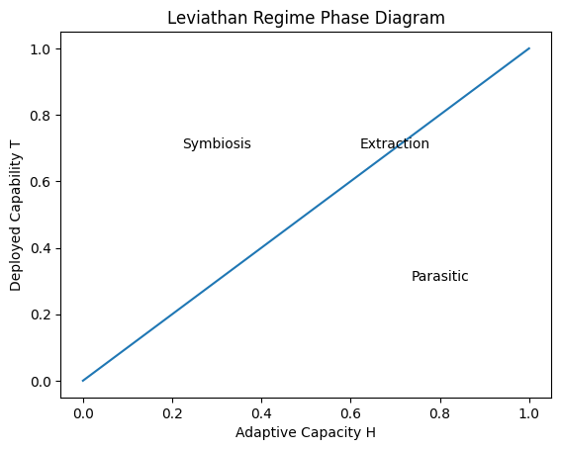

Mathematical Foundation of the Pivot Condition dT_deploy/dt ≈ B(H)
This section develops both sides of the deployment–adaptation balance from first principles, culminating in the practical control-law form dT_deploy/dt ≈ B(H). The intent is to make the framework fully closed-loop: starting from measurable processes that generate deployment velocity and adaptive bandwidth, and ending at the inequality that separates symbiosis from divergence.

1. Preliminaries and interpretation
Recall the two coupled quantities: deployed capability T_deploy(t) and human adaptive capacity H(t). The left-hand side dT_deploy/dt is the realized velocity at which new capability is introduced into the social substrate (products, infrastructure, automation, policy-relevant functionality). The right-hand side B(H) is the maximum safe introduction rate the civilization can absorb without loss of coherence, trust, or utilization stability.
dT_deploy/dt ≤ B(H)
Operationally, the stabilized regime is often achieved by regulating toward near-equality (critical pacing):
dT_deploy/dt ≈ B(H)

2. Left-hand side: deriving deployment velocity dT_deploy/dt

2.1 Potential P and conversion to deployed capability
We distinguish latent technological potential P(t) from deployed capability T_deploy(t). P captures research results, prototypes, compute/energy availability, manufacturing capacity, and algorithmic advances. Only a fraction of P becomes socially active capability each unit time.
P(t) → (conversion) → T_deploy(t)
A minimal conversion model is:
dT_deploy/dt = κ(t) · P(t)
where κ(t) is an effective conversion coefficient summarizing incentives, regulatory gating, capital availability, supply chain throughput, and productization pipelines. In high-competition environments κ rises, pushing faster deployment.

2.2 Baseline exponential push: r-driven growth
In many sectors the unconstrained capability trajectory follows an approximate exponential envelope:
dT/dt = rT
Absent pacing, deployment tends to chase this envelope via product releases, automation rollouts, and infrastructure buildout:
dT_deploy/dt ≈ r_eff · T_deploy
Here r_eff absorbs the distinction between raw technological growth and deployment pressure (including commercialization cycles).

2.3 Pacing / gating as a control input
Let u(t) ∈ [0,1] represent a policy/engineering gate that throttles conversion from potential into deployment (staged release, certification gates, scale limits, access tiers). Then:
dT_deploy/dt = u(t) · r_eff · T_deploy
Symbiosis is achieved not by suppressing P outright, but by controlling u(t) so that the realized deployment velocity remains inside the adaptive corridor.

3. Right-hand side: deriving adaptive bandwidth B(H)

3.1 Adaptive equilibrium H_e(T) and tracking
Define H_e(T_deploy) as the equilibrium adaptive capacity implied by holding deployed capability constant long enough for institutions, skills, norms, and coordination mechanisms to assimilate it.
H_e = f(T_deploy)
A standard first-order tracking model is:
dH/dt = a(H_e(T_deploy) − H)
where a is the adaptation rate constant (training throughput, regulatory update cadence, standards diffusion, operational learning, incident-response capacity).

3.2 Bandwidth as maximum safe correction rate
Adaptive bandwidth B(H) is the maximum safe rate at which deployed capability can increase while allowing H to track its moving equilibrium. One way to define it is as the maximum dT_deploy/dt for which tracking error E(t)=H_e−H remains bounded.
E(t) = H_e(T_deploy) − H
Differentiate E(t):
dE/dt = (dH_e/dT_deploy)·(dT_deploy/dt) − dH/dt
Substitute dH/dt = aE:
dE/dt = (dH_e/dT_deploy)·(dT_deploy/dt) − aE
To keep E bounded (no runaway lag), the forcing term must not dominate correction over relevant horizons. In corridor operation, we demand that deployment forcing be less than or comparable to correction capacity:
(dH_e/dT_deploy)·(dT_deploy/dt) ≤ aE_max
Define β(T_deploy)=dH_e/dT_deploy as the marginal adaptive requirement per unit deployed capability. Then a natural bandwidth definition is:
B(H) = (a/β) · E_max
E_max encodes tolerance for mismatch before trust, governance, or utilization degrade (corridor width). As H_max increases and institutions become more robust, both a and E_max can rise, increasing B(H).

3.3 Practical proxies for B(H)
Empirically, B(H) corresponds to institutional throughput: how fast society can train, regulate, audit, standardize, and respond to incidents introduced by new capability. Proxies include retraining capacity, regulatory update cycle time, standards adoption time, audit coverage, and incident-response mean time to resolution.

4. Closing the loop: from inequality to near-equality control
Combining the derived forms yields the pivotal constraint:
u(t)·r_eff·T_deploy ≤ B(H)
In corridor-stabilized operation, u(t) is chosen so that the system runs near critical pacing:
u(t)·r_eff·T_deploy ≈ B(H)
This is the core interpretation: Leviathan becomes tameable when the civilization builds measurement and control capacity sufficient to modulate u(t) in response to observed mismatch and bandwidth.

5. Evidence from current-world conditions
Current conditions in energy, compute, and surveillance provide observable signals consistent with mismatch dynamics: deployment pressure rising faster than adaptation and legitimacy formation.

5.1 Energy allocation tension and data-center growth
Data-center electricity demand has become a measurable stressor on grids and a trigger for local political resistance. The International Energy Agency projects global electricity consumption for data centres to roughly double to around 945 TWh by 2030 in its base case, growing around 15% per year from 2024 to 2030—more than four times faster than total electricity demand growth. This is a concrete example of rapid T_deploy growth competing for civil energy resources, which can suppress effective H by reducing perceived exchange fairness and increasing backlash.
Source: International Energy Agency (IEA), Energy and AI (2024), “Energy demand from AI / data centres”.
Pew Research summarizes IEA estimates that U.S. data centers consumed 183 TWh of electricity in 2024—over 4% of U.S. electricity consumption—and projects substantial growth by 2030. Such concentrations generate local bottlenecks and political contestation, which in the model manifest as reductions in effective integration Φ(H,G) and thus demand stability.
Source: Pew Research Center, “What we know about energy use at U.S. data centers amid the AI boom” (Oct 24, 2025).

5.2 Surveillance deployment before acceptance and legitimacy
Surveillance-capable technologies illustrate mismatch when capability is deployed into governance contexts before robust legitimacy, transparency, and oversight are in place. The U.S. Commission on Civil Rights notes the absence of comprehensive federal laws or regulations expressly authorizing or limiting federal facial recognition technology use (as of mid-2024), indicating institutional lag relative to capability deployment.
Source: U.S. Commission on Civil Rights, “The Civil Rights Implications of the Federal Use of Facial Recognition Technology” (Sep 19, 2024).
Civil-liberties analyses argue that rapid expansion of face recognition and related surveillance can outpace constraints and public consent, producing trust shocks that reduce effective adaptive capacity. In the model, these appear as an increased tracking error E(t) and a narrowing of tolerance E_max (lower corridor width), thereby reducing B(H) exactly when deployment pressure rises.
Source: American Civil Liberties Union (ACLU), surveillance technologies commentary (2025–2026).

6. Implication for Fermi civilizations and space expansion
Interplanetary expansion amplifies Leviathan characteristics: higher fixed costs, longer maintenance horizons, and tighter reliability requirements. A civilization that cannot keep dT_deploy/dt within B(H) at planetary scale is unlikely to sustain the coherent long-horizon infrastructure needed for off-world expansion. Thus the Fermi bottleneck can be reframed as a bandwidth bottleneck: civilizations fail not from lack of capability but from failure to stabilize the conversion of potential into deployed power within adaptive limits.
Expansion capability requires: dT_deploy/dt ≤ B(H) sustained over long horizons

References
International Energy Agency (IEA). Energy and AI (2024): Energy demand from AI / data centres.
Pew Research Center. What we know about energy use at U.S. data centers amid the AI boom (Oct 24, 2025).
U.S. Commission on Civil Rights. The Civil Rights Implications of the Federal Use of Facial Recognition Technology (Sep 19, 2024).
American Civil Liberties Union (ACLU). Surveillance technologies and face recognition commentary (2025–2026).

